Project Design Phase-II

Data Flow Diagram & User Stories

|  |  |
| --- | --- |
| Date | 03 November 2022 |
| Team ID | PNT2022TMID43019 |
| Project Name | Nutrition Assistant Application |
| Maximum Marks | 4 Marks |

# Data Flow Diagrams:

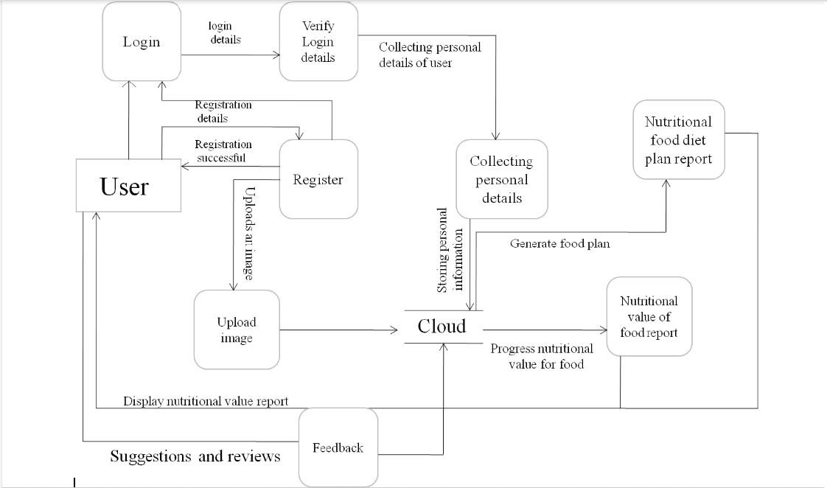

# User Stories

|  |  |  |  |  |  |  |
| --- | --- | --- | --- | --- | --- | --- |
| **User Type** | **Functional Requirement (Epic)** | **User Story Number** | **User Story / Task** | **Acceptance criteria** | **Priority** | **Release** |
| Customer (Mobile  user) | Registration | USN-1 | As a user, I can register for the application by entering my email, password, and confirming my password. | I can access my account / dashboard | High | Sprint-1 |
|  |  | USN-2 | As a user, I will receive confirmation email once I have registered for the application | I can receive confirmation email & click confirm | High | Sprint-1 |
|  | Login | USN-3 | As a user, I can log into the application by entering email & password | I can login when password and email are correct | High | Sprint-1 |
|  | Collecting personal details | USN-4 | As a user,I can provide a personal information for processing | I can enter the personal details | Medium | Sprint-1 |
|  | Upload image | USN-5 | As a user,I can upload an image for the processing of food. | I can upload a food image. | High | Sprint-1 |
|  | Feedback | USN-6 | As a user,I can give feedback | I can give feedback about the application | Low | Sprint-1 |
| Cloud | Nutritional value of report | USN-7 | In cloud the food image is processed and provides the nutritional value of food. | It gives the nutritional value of food. | High | Sprint-2 |
|  | Nutritional food diet plan report | USN-8 | In cloud the food diet plan based on nutritional value is  generated based on the personal information provided by the user. | It provides the diet nutritional plan. | Medium | Sprint-2 |